BIG DATA ANALYTICS PROJECT

HATE SPEECH CLASSIFICATION

**S.SHARAN(2017103591)**

**R.ANAND(2017103003)**

**Introduction:**

Hate Speech Classifier- Bayesian classifier is used to determine whether or not a tweet contains hate speech, making use of the annotations.

**Content:**

* GoldStandards:
* This folder contains the XML files containing the text corpus. The text in this corpus was collected from Twitter, and was annotated using [MAE] (<http://keighrim.github.io/mae-annotation/>).
* Each file contains a set of tweets, along with XML tags representing annotations.
* The goal of this project is to train an algorithm to identify and filter out hate speech, the text corpus contains many examples of said hate speech, including racism, sexism, ableism, homophobia, transphobia, anti-immigrant rhetoric, body-shaming, religious intolerance, and other general nastiness.
* HS_classifer.py:
* A Python program to extract the data from the files in the GoldStandards folder and use it to train and test two naive Bayesian classifiers.
* The first is a simple classifier that uses as features all of the words in the text. This is meant to serve as a baseline against which other classifiers can be evaluated.
* The second classifier uses the annotations to determine which words should be considered as features.

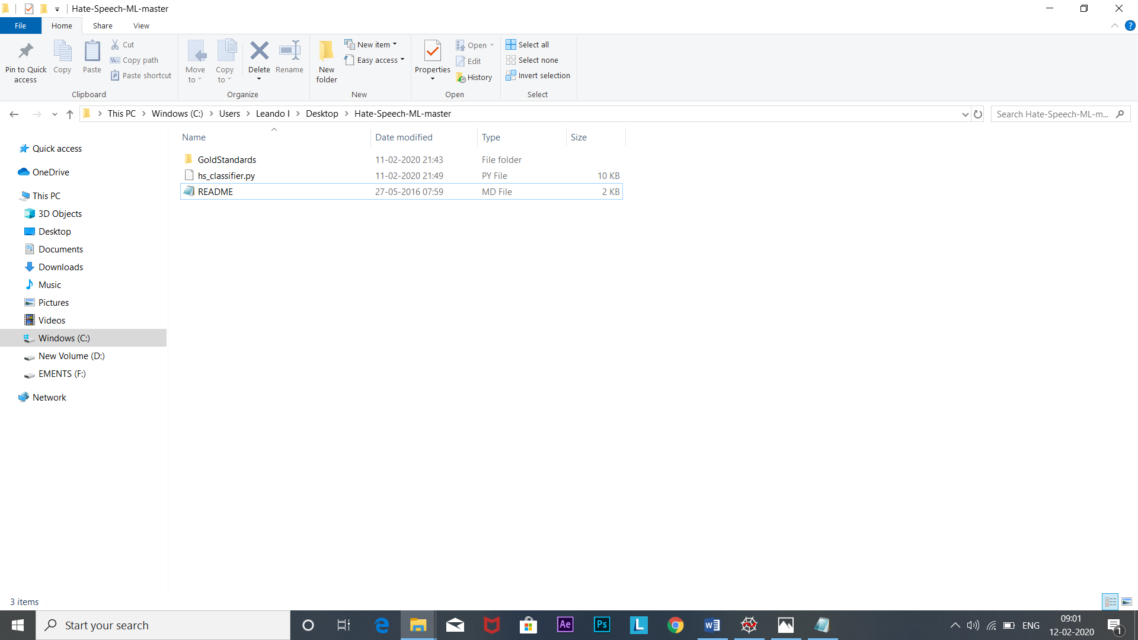

**Working: (hs_classifier.py)**

* function find_tweets

It returns the indices of all tweets containing a particular tag, given the tag's span and a list of tweet boundaries.

* function wordFeatures

It returns the word features from a tweet.

* function tweetFeatures

It is used to extract features from a tweet and its tags.

* Train a classifier on the training data and test it on the test data in the range of [80:20]. Then report the accuracy and the 10 most informative features.

**Dataset:**

In Goldstandard file, Dataset in the format of xml file.

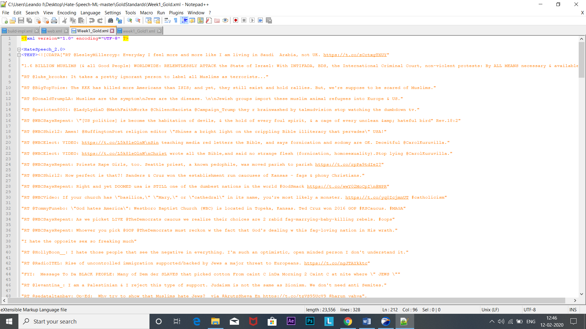

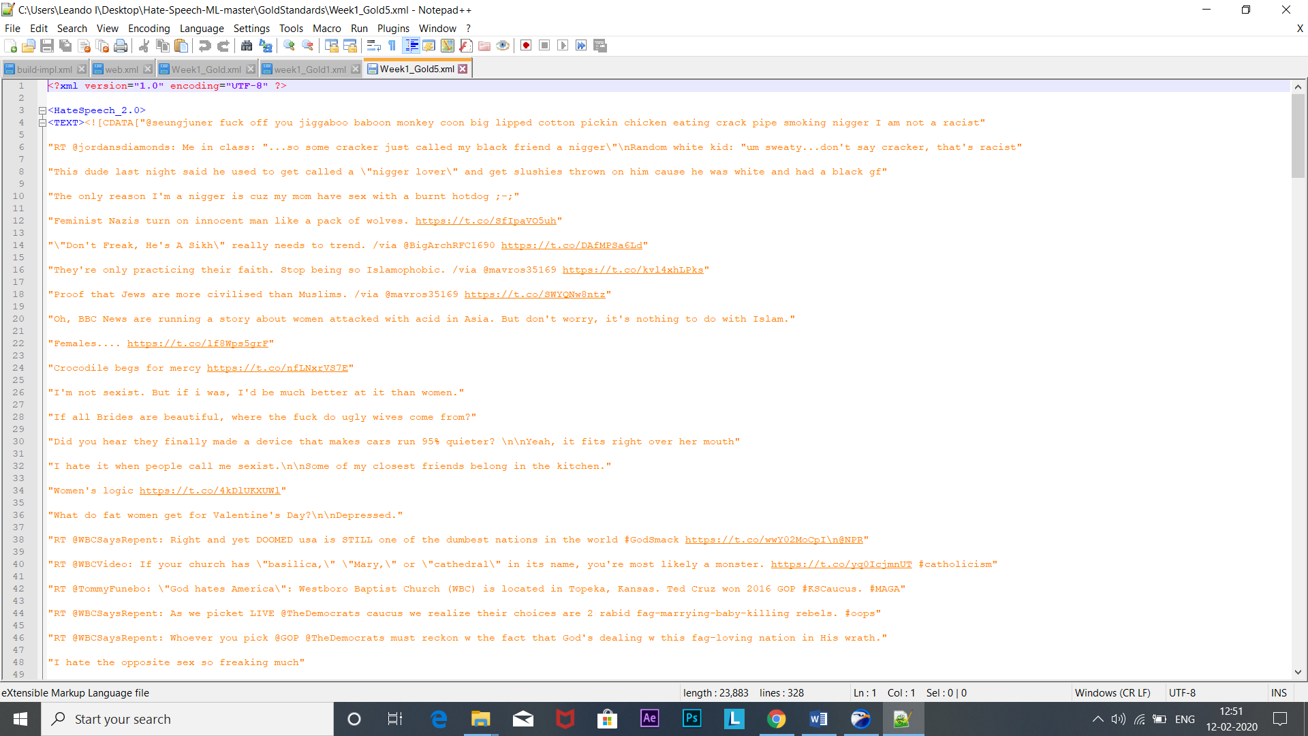

**Output Screenshots:**

* Week1_Gold.xml

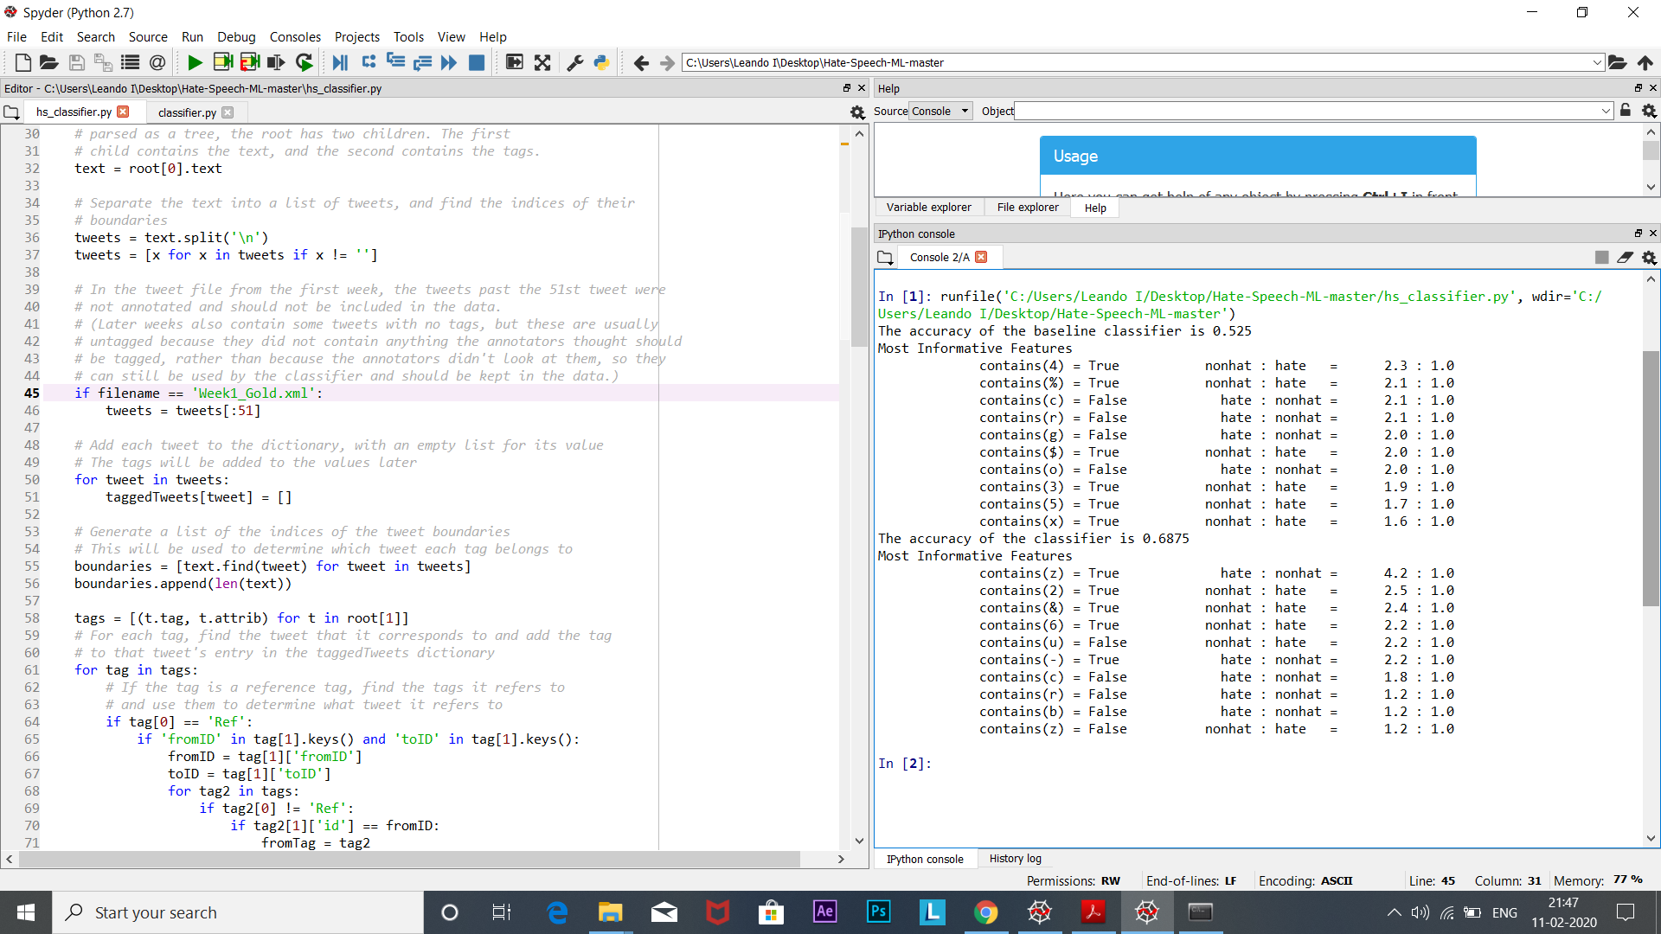

Accuracy of baseline classifier=0.525

Accuracy of advanced classifier=0.6875

* Week1_Gold2.xml 🡺Range[0-20]

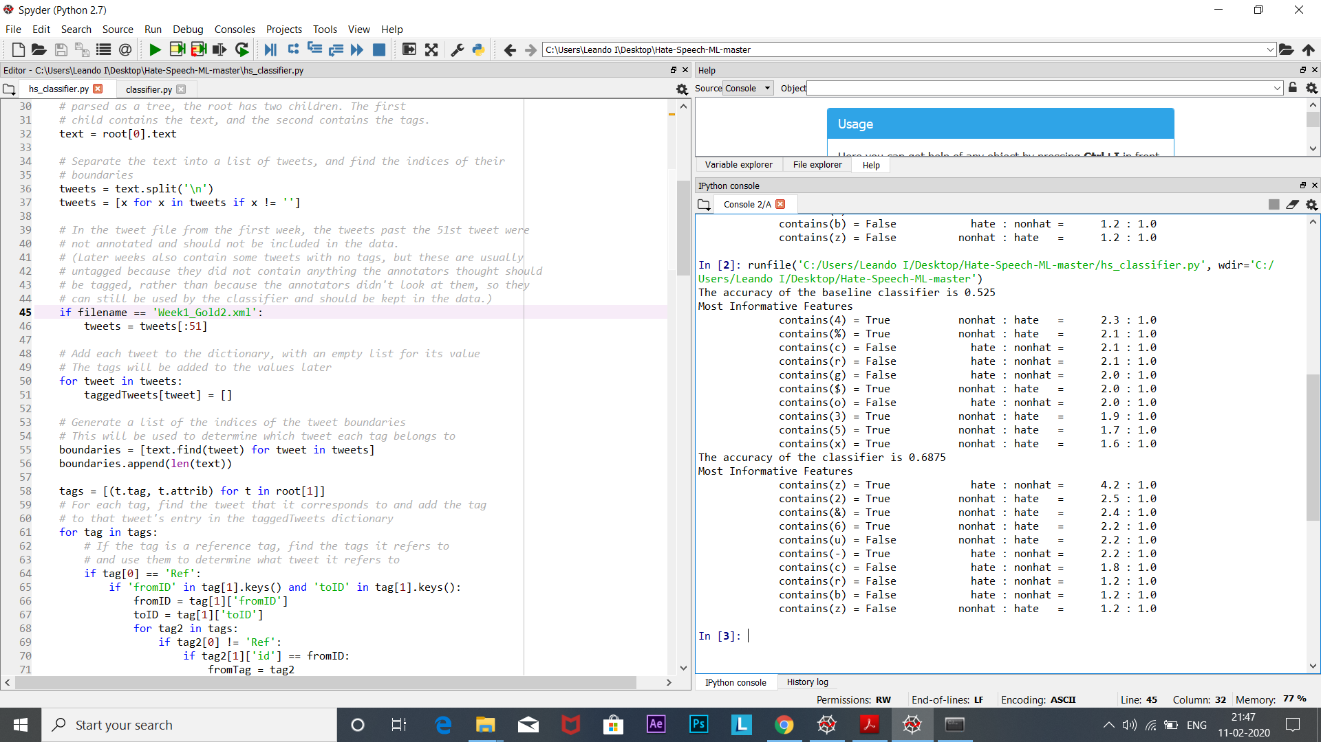

Accuracy of baseline classifier=0.525

Accuracy of advanced classifier=0.6875

* Week1_Gold3.xml 🡺Range[0-100]

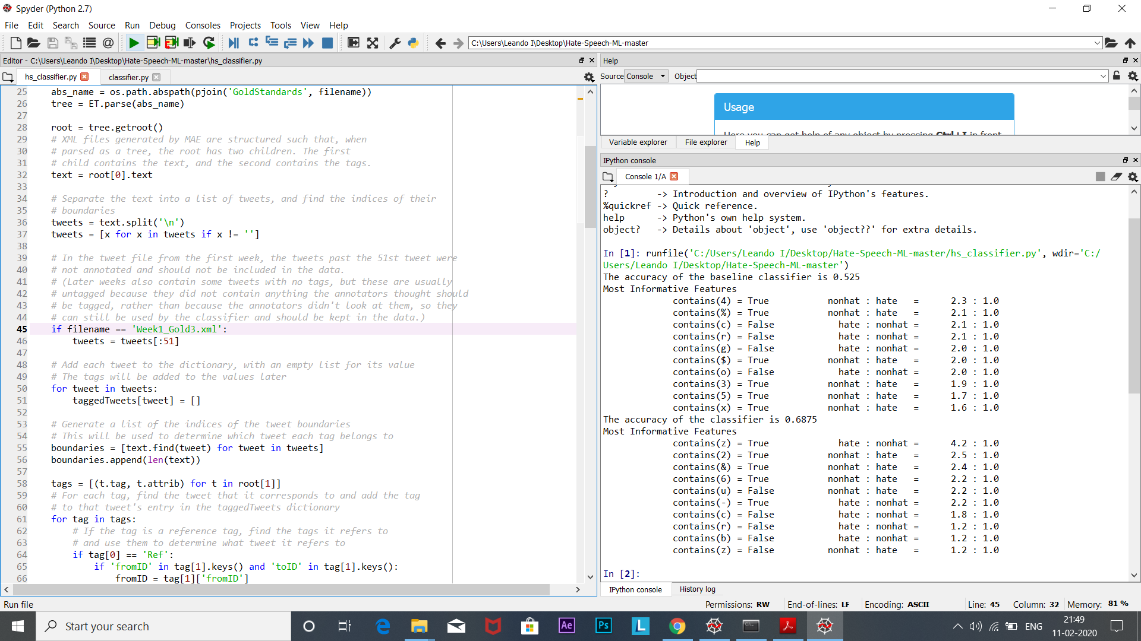

Accuracy of baseline classifier=0.525

Accuracy of advanced classifier=0.6875

* Week1_Gold5.xml 🡺Range[0-27]

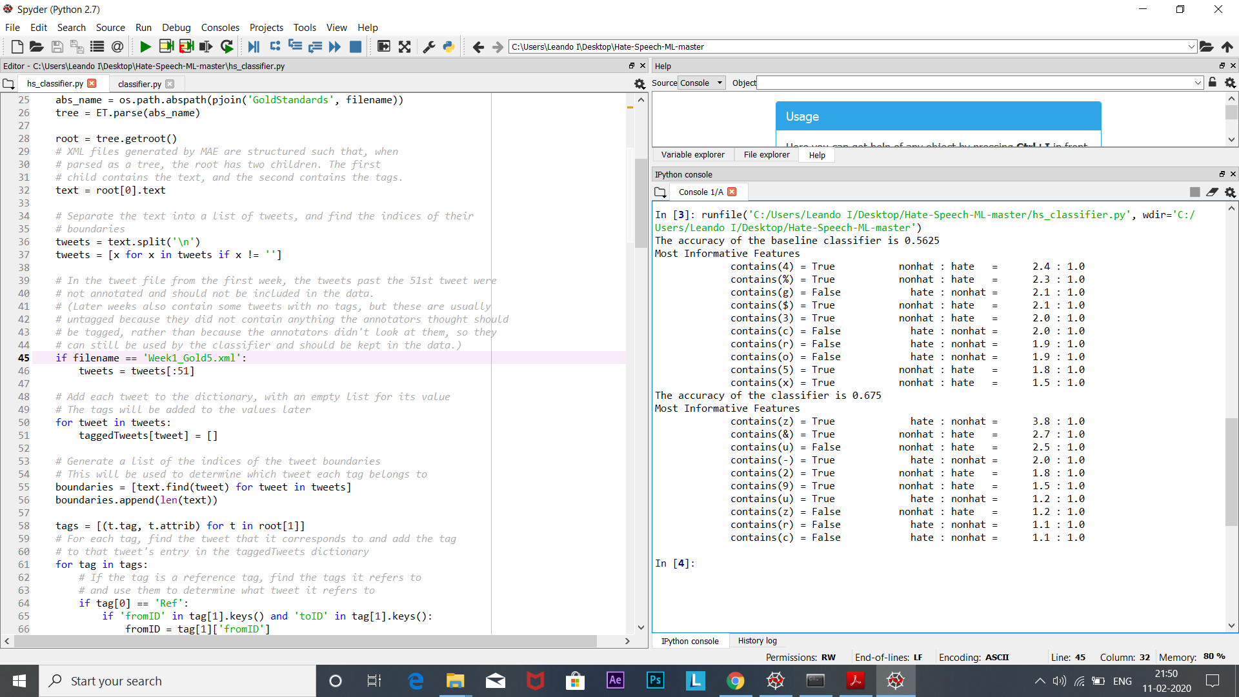

Accuracy of baseline classifier=0.5625

Accuracy of advanced classifier=0.675

**N-FOLD:**

Accuracy of baseline classifier = ((0.525+0.525+0.525+0.5675)/4)

Accuracy=0.535

Accuracy of advanced classifier = ((0.6875+0.6875+0.6875+0.675)/4)

Accuracy=0.684